**Proposed Title:**

“NoSql to RDBMS converter”

**Field of Invention:**

1. **Database Management Systems (DBMS):** This field encompasses the study, development, and management of various database systems, including NoSQL and RDBMS. A NoSQL to RDBMS converter is a tool that bridges the gap between these two types of systems.
2. **Data Integration:** Data integration focuses on the processes and technologies used to combine data from different sources, formats, and structures. A NoSQL to RDBMS converter is a component of data integration, as it involves converting data from one database format (NoSQL) to another (RDBMS).
3. **Big Data:** In the context of big data, organizations often deal with a variety of data sources and storage solutions. NoSQL databases are commonly used for handling unstructured or semi-structured data, while RDBMS is used for structured data. A converter can help integrate and process data across these systems within a big data environment.
4. **Database Transformation:** Database transformation is the process of changing the structure, schema, or format of a database. A NoSQL to RDBMS converter transforms the data structure and schema from a NoSQL format to an RDBMS format.
5. **Data Warehousing:** Data warehousing involves the collection and storage of data from various sources for analysis and reporting. A converter can be used to integrate data from NoSQL databases into a data warehouse based on an RDBMS.

**Background:**

NoSQL databases have gained popularity for their flexibility in handling large volumes of unstructured or semi-structured data. However, there are scenarios where utilizing a traditional RDBMS can be more suitable due to its well-defined schema and efficient query capabilities. Migrating data from NoSQL to RDBMS while maintaining data consistency and relationships presents a technical challenge that this invention addresses.

**Objective:**

1. **Schema Transformation:** The project aims to transform the schema and data structure from NoSQL to a format suitable for an RDBMS.
2. **User-friendly Interface:** The project should provide a user-friendly interface that allows users to initiate and manage data conversion tasks easily.
3. **Single-Platform for Different File Conversions:** The project aims to convert different types of Nosql files (e.g. .csv, .xml, .json, etc.) into RDBMS files.
4. **Secure Platform :** The project aims to provide a secured website that takes care of the privacy and data integrity of the user’s data

**Diagrams:**

**Flow Chart:**

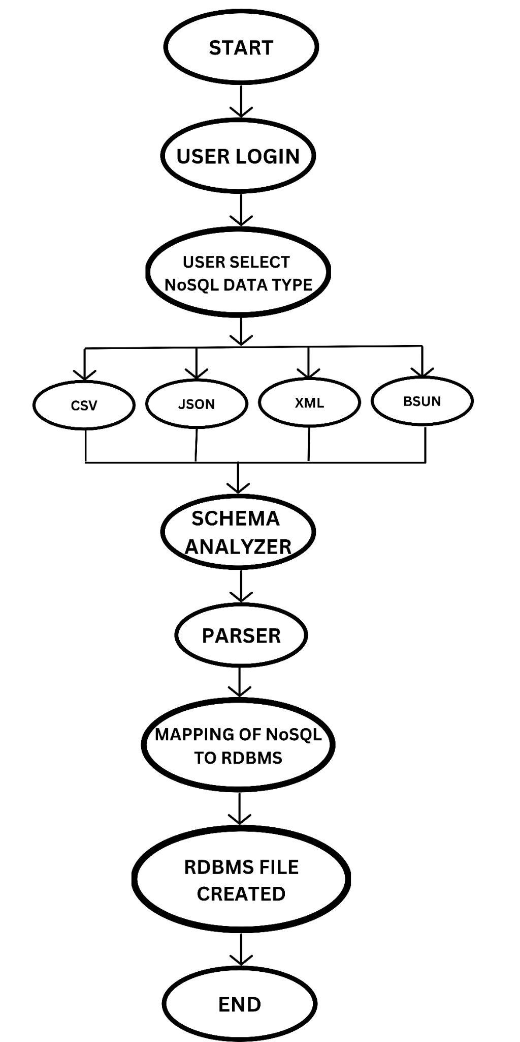

**Claim:**

"Our website is unique because it offers a combination of features that no other platform provides; it supports three input file formats, including CSV, JSON, and XML, and seamlessly converts them into a single output RDBMS file individually."

**Technology Used:**

1. **PHP:** PHP is the primary programming language for building the converter.
2. **XAMPP:** XAMPP is an all-in-one web server solution that includes PHP, Apache web server, MySQL (or MariaDB), and PHPMyAdmin. It provides a local development environment for PHP-based projects.
3. **Database Connectors:**

**MongoDB:** Use a PHP MongoDB library like the official MongoDB PHP driver (mongodb) to connect to and interact with MongoDB databases.

**RDBMS (e.g., MySQL or MariaDB):** XAMPP includes MySQL (or MariaDB), so you can use PHP's built-in MySQL functions or the PDO extension for connecting to and working with relational databases.

1. **Data Serialization/Deserialization:**

**JSON:** PHP provides built-in support for working with JSON data using functions like json_encode and json_decode.

**XML:** You can use PHP's SimpleXML or DOMDocument for handling XML data.

**CSV:** PHP offers functions like “fgetcsv” and “fputcsv” for manipulating CSV data.

1. **ETL Logic:** Implement the ETL logic using PHP to extract data from the NoSQL source, transform it as needed, and load it into the RDBMS.

**Abstract:**

A system and method are disclosed for converting data from a NoSQL database to a Relational Database Management System (RDBMS) format. The system comprises a converter module that facilitates seamless migration of data while preserving data integrity and relational structures. The method involves analyzing the schema of the NoSQL database, mapping it to an RDBMS schema, and efficiently transforming and loading the data into the target RDBMS.

**End-Users:**

1. **Data Engineers:** Data engineers are responsible for designing and managing data pipelines. They may use the converter to facilitate the ETL (Extract, Transform, Load) process when moving data from NoSQL databases to RDBMS for analysis or reporting.
2. **Database Administrators (DBAs):** DBAs may use the converter to assist in database migration or integration tasks, ensuring data consistency and optimizing database performance.
3. **Business Analysts:** Business analysts may benefit from the converter when they need to access and analyze data from various sources, including NoSQL databases, in their reporting and decision-making processes.
4. **IT Operations:** IT operations teams responsible for maintaining the organization's database infrastructure may use the converter during database migration projects or when integrating data from different sources.
5. **Data Scientists:** Data scientists working on analytics or machine learning projects may use the converter to access data stored in NoSQL databases and bring it into a structured format suitable for analysis.
6. **Business Users:** Depending on the organization's structure and goals, business users who rely on data for their daily operations and decision-making may benefit indirectly from the converter by having access to well-structured and integrated data.

**Advantages:**

1. Preserves data consistency during migration.
2. Enables efficient querying using the capabilities of RDBMS.
3. Provides a structured approach for migrating NoSQL to RDBMS.
4. Supports migration of various NoSQL databases to multiple RDBMS systems.

**Conclusion:**

The disclosed system and method provide a novel solution for converting data from NoSQL databases to the structured format of RDBMS systems. By addressing the technical challenges of schema mapping, data transformation, and data integrity, this invention enables seamless migration of data while leveraging the benefits of relational databases.

**Authors List:**

| **NAME** | **EMAIL** | **E-SIGN** |
| --- | --- | --- |
| Vageesha Rai | vageesha.2024cs119@kiet.edu |  |
| Vikas Kumar Verma | vikas.2024cs1061@kiet.edu |  |
| Saumya Singh | saumya.2024cs1132@kiet.edu |  |